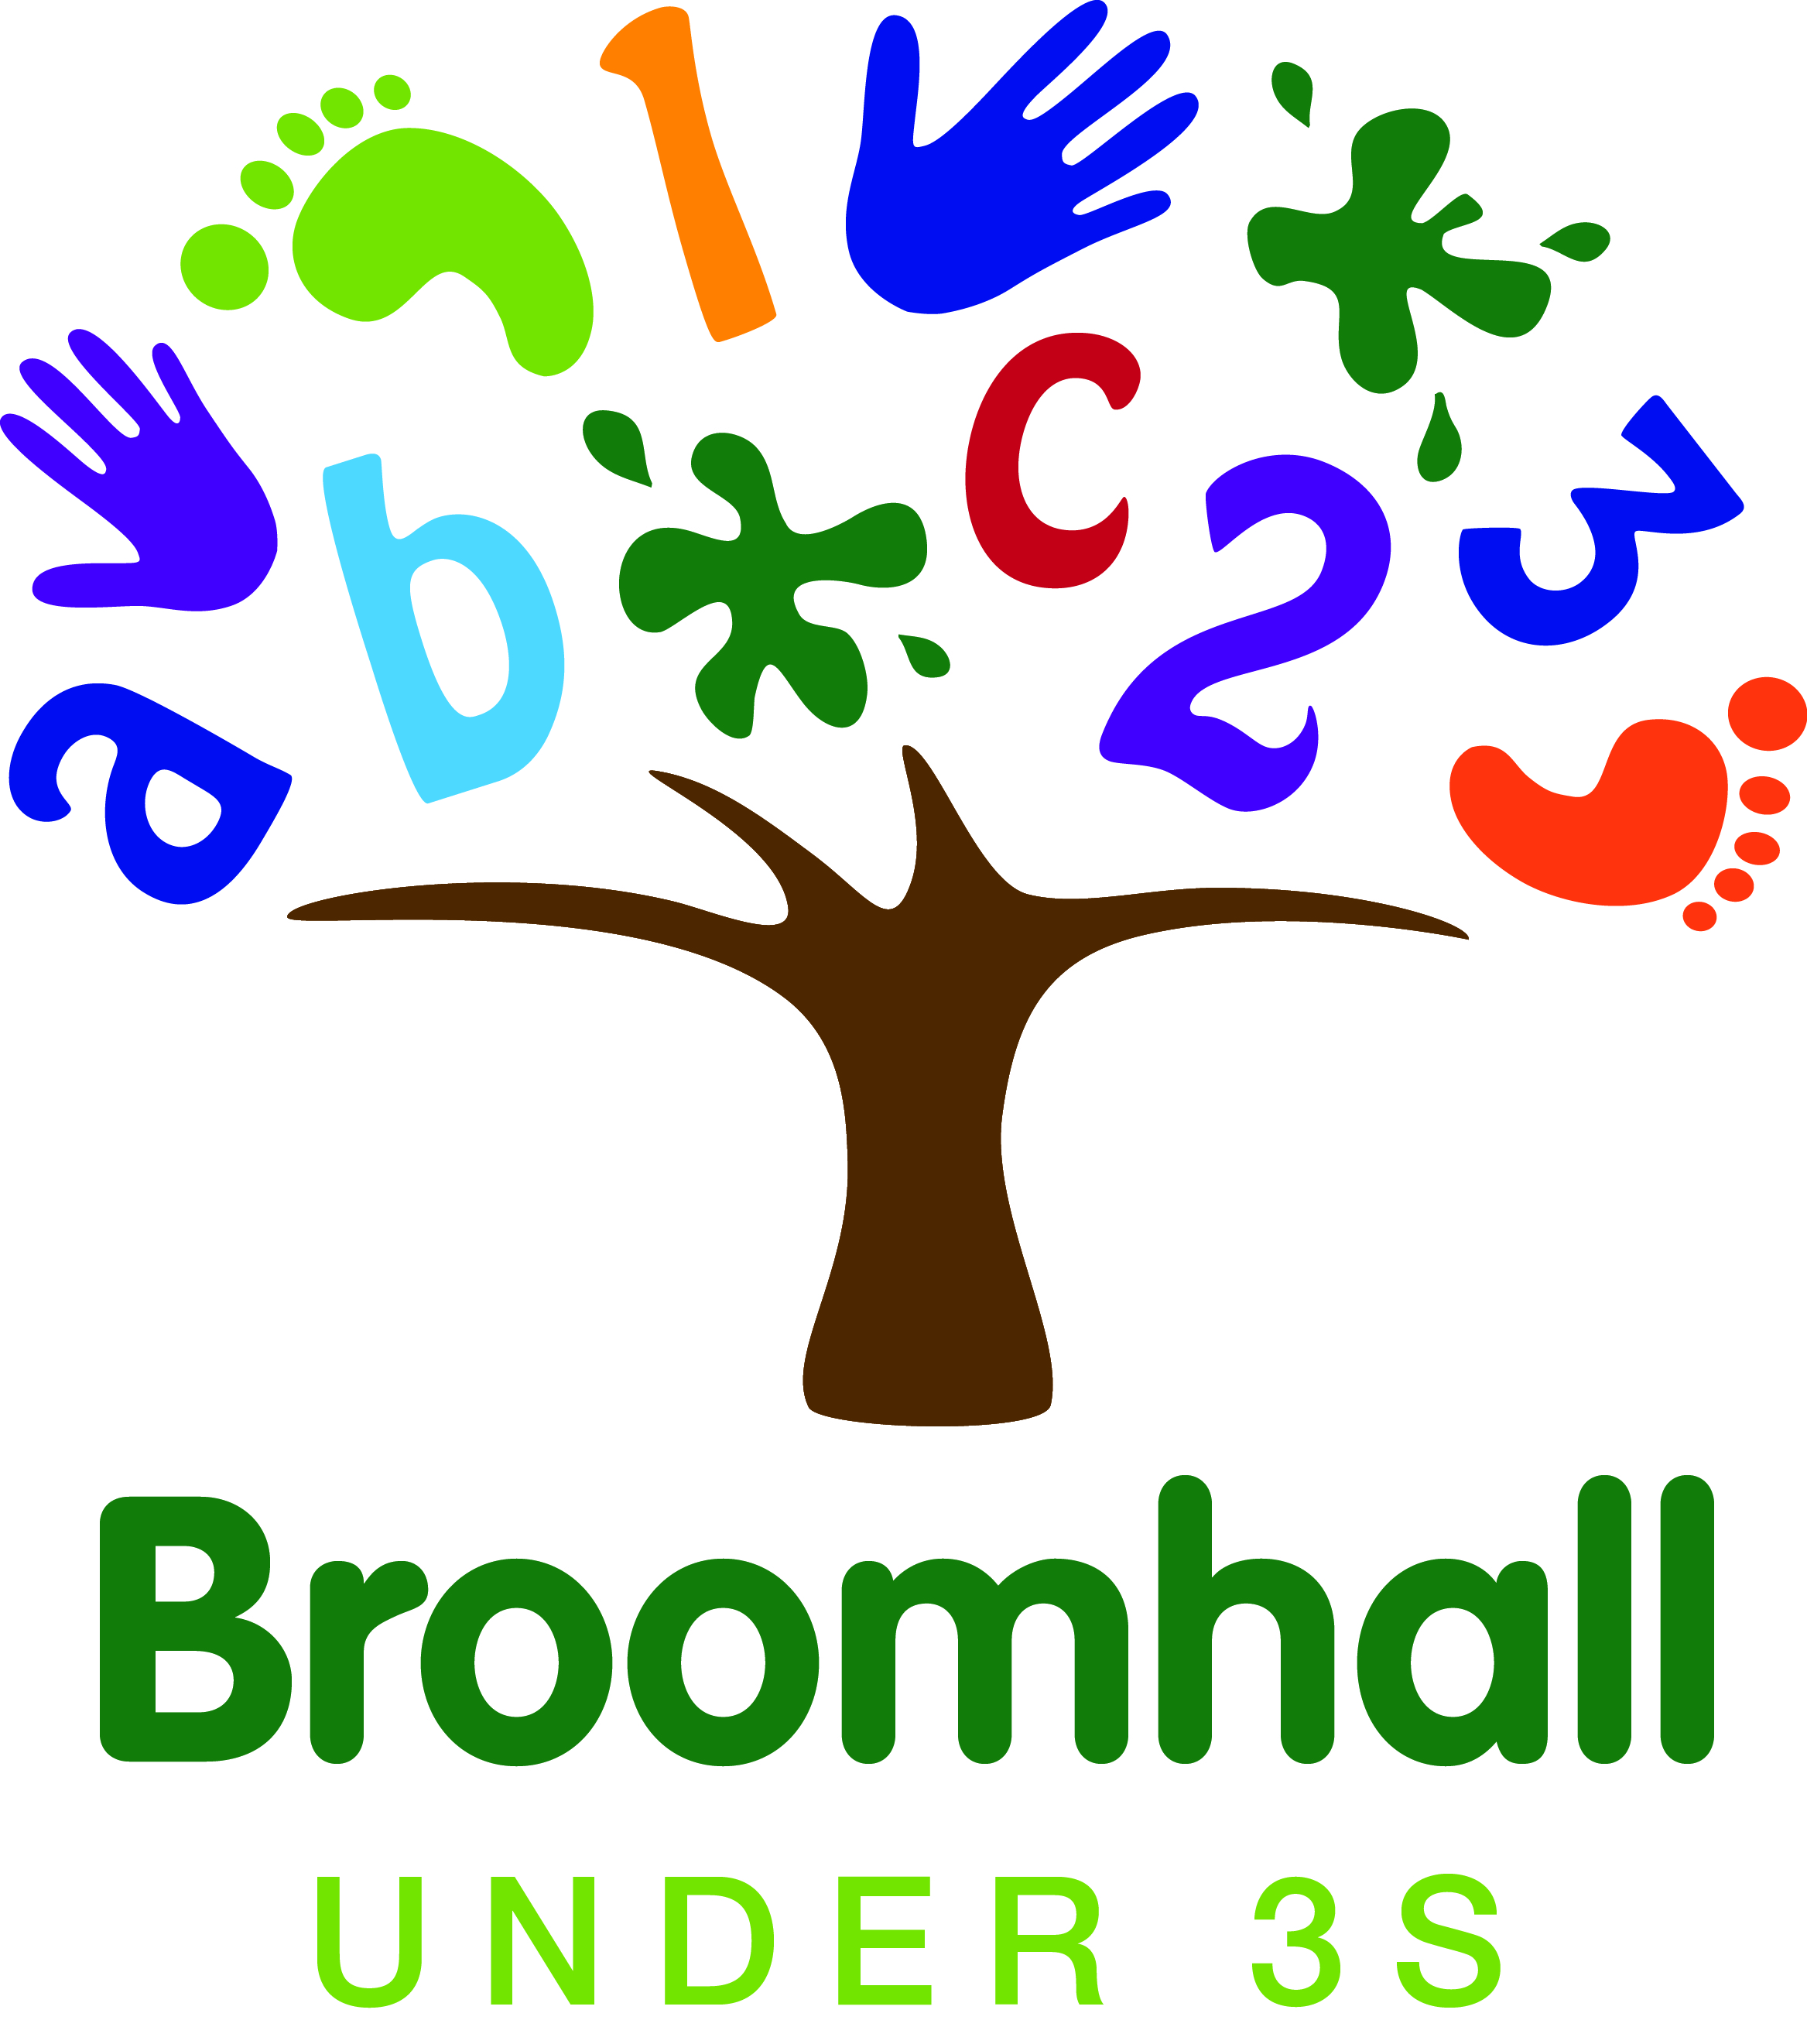

Application & Admissions Form
If you need help with this form please contact a member of staff.
Please complete all sections using BLOCK CAPITALS.
1. Child Details

4 Broomhall Road, Sheffield S10 2DN
Tel: 0114 2721453
Email: info@broomhallunder3s.co.uk

First Name(s): | Surname:
Date of Birth: | Boy ☐ Girl ☐
Address:
Postcode:

2. Parent/Carer Details
 | Parent/Carer 1 |  |  | Parent/Carer 2
Title e.g. Mr/Mrs/Ms/Miss/Dr
First & Second Name
Date of Birth
Address
If different from child

Home Telephone
Mobile Telephone
Work Telephone
Email
Relationship to child
Has Parental Responsibility | Yes ☐ No ☐ |  |  | Yes ☐ No ☐
NI Number
Other family members/adults at child’s address
Name  Relationship to child |  |  | Name  Relationship to child
Name  Relationship to child |  |  | Name  Relationship to child
Other significant adults/frequent visitors who regularly visit the home or who are part of the family support network.
Name  Relationship to child  Telephone contact |  |  | Name  Relationship to child  Telephone contact
People (over the age of 16) with permission to collect your child from nursery.
Name  Relationship to child  Telephone contact |  |  | Name  Relationship to child  Telephone contact
Are there any special circumstances or information that we should know about in order to help and support you and your child e.g. family situations, restrictions on collecting, etc?
3. Sessions Requested
Please note that we are only open during school term-time. From the term after their 2nd birthday some children are eligible for 15 hours Free Early Learning (FEL). Please see a member of staff for details.
SESSION | Monday | Tuesday | Wednesday | Thursday | Friday
BREAKFAST CLUB 8.00am-9.00am
CORE MORNING 9.00am-11.30am
LUNCH 11.30am-1.00pm
CORE AFTERNOON 1.00pm-3.30pm
TEA CLUB 3.30pm-5.00pm
When do you want this place to start?

4. Additional Information
4.1 Child’s Ethnic Origin, Language & Religion
This information is required by the Local Authority. Please tick the relevant box.
White | Black or Black British | Mixed / Dual Background
British WHB ☐ | Caribbean BLB ☐ | White & Black Caribbean WMB ☐
Irish WHR ☐ | Somali BSO ☐ | White & Black African MBA☐
Traveller or Irish Heritage WHT ☐ | Other Black African BAO ☐ | White & Pakistani MWP ☐
Gypsy / Roma WRO ☐ | Any other Black background BLG ☐ | White & any other Asian background MWS ☐
Eastern European WEA ☐ | Asian or British Asian | Any other mixed background MOT ☐
Other WHA ☐ | Bangladeshi ABA ☐ | Any other background
Chinese | Indian AIN ☐ | Yemeni OYE ☐
Chinese CHE ☐ | Pakistani APK ☐ | Any other ethnic group OOE ☐
 | Any other Asian background AAO ☐
Place of birth:
Nationality:
Home Language
Religion:

4.2 Health Information
Doctor’s name & contact details:

Please give details of any health issues we should know about e.g. allergies, dietary, serious illness or injury.

Please give details of any additional needs or development concerns about which we should know e.g. language & communication, physical disability, sensory, behaviour, etc.
Please give details of any services offering support to your family e.g. Social Worker, Health Visitor, Therapists, MAST

In an emergency where urgent medical attention is needed and I cannot be contacted to authorise this, I hereby give my general consent to any necessary medical treatment and authorise Nursery to sign any document required by the hospital authorities. For less urgent medical treatment, where an ambulance is not required, I understand that staff cars (fully insured) may be used to take my child to the A&E department of Sheffield Children’s Hospital. |  | Agree  ☐ | Don’t Agree  ☐

5. Permissions
5.1 Photographs & Video  Please indicate your agreement to use of your child’s photograph by ticking the relevant box. | Agree | Don’t agree
To record your child’s learning as part of their progress record which will be passed on to their infant/primary school when they leave Broomhall Nursery. | ☐ | ☐
For use in displays in nursery. | ☐ | ☐
For use on our promotional literature e.g. posters and leaflets | ☐ | ☐
For use on our website, Facebook page and Twitter feed. In the interests of safeguarding children’s names are not associated with photographs posted on these sites. | ☐ | ☐
On occasions Press and TV journalists may wish to take photographs and/or record video footage of special events at nursery during which time your child may be included. | ☐ | ☐
Students from Sheffield Universities (DBS checked) undertake observational research projects in nursery. Individual children are not identified in the findings of the research. | ☐ | ☐

6. Early Years

6.1 Nursery Attendance
Does your child attend any other nursery/childcare provision? Please give details.
If you are leaving your existing provision to take up FEL hours at Broomhall Under 3s you are required to give 4 weeks’ notice to your existing provider.

Signature of Parent/Carer: | Date:

